**Inspection Requirement**

When a structure or facility is to be demolished or renovated, an inspection, conducted by a certified individual and company, is required (UAC R307-801-9). An asbestos inspection report must be generated, and available on-site to all persons who have access to the work site. Furthermore, the asbestos inspection report must be maintained by the operator or owner for one year after the completion of the project. The asbestos inspection report contains the following information:

1. a brief description of area;
2. a list of all suspect materials identified in affected area;
3. a list of samples collected from affected area;
4. a statement of the asbestos content of each sample or materials assumed to contain asbestos; and
5. a list of potential locations of suspect materials that were not accessible during initial inspection (UAC R307-801-10).

Contact the Utah Division of Air Quality at: (801) 536-4000

www.deq.utah.gov/ProgramsServices/
programs/air/asbestos/index.htm

Questions?

Contact the
Utah Division of Air Quality
(801) 536-4000

For Utah Certified Asbestos Inspector and Contractor lists, notification forms, and information about Utah asbestos rules, see our web page:

www.deq.utah.gov/ProgramsServices/
programs/air/asbestos/index.htm

Version 1.0 DAQA-712-15

Renovation or Demolition?
What you need to know before
you start

Utah Division of Air Quality

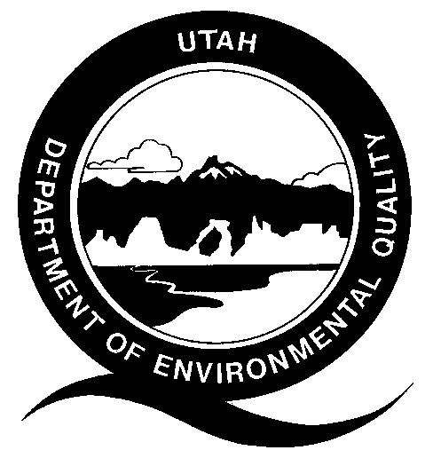

195 North 1950 West
PO Box 144820
Salt Lake City, Utah 84114-4820

Phone (801) 536-4000
Fax (801) 536-4099

Are you Remodeling or Renovating?

You are subject to Federal Regulations
40 CFR 61.145(a) and/or Utah Administrative Code (UAC) R307-801-9 requiring inspection for asbestos.

Avoid asbestos exposure by workers and building occupants, penalties and delays. Have your project inspected for asbestos by a State Certified asbestos inspector before commencing work.

It is illegal to improperly disturb asbestos-containing materials.

Asbestos can be found in these common building materials: ceiling textures, vinyl floor coverings and mastic, boiler and pipe insulation, ceiling tile, roofing products, asbestos-cement shingles, and many other building materials. Many of these materials can release harmful asbestos fibers and are regulated. A certified asbestos inspector can determine which materials contain asbestos and which are regulated.

For ALL Renovation Projects:

Structures/components to be disturbed must be Inspected for Asbestos.

Buildings of any age may contain asbestos, even those newly built may have asbestos containing materials.

Asbestos containing materials that are regulated or may become regulated must be removed by a certified asbestos abatement contractor before they are disturbed by renovation activities.

A written notification to Utah DAQ, payment of a notification fee and 10 working day waiting period may be required before the removal of large amounts of regulated asbestos-containing materials.

Regulated asbestos-containing waste material must be disposed of at an approved asbestos waste disposal site.

Contact the Utah Division of Air Quality at: (801) 536-4000

www.deq.utah.gov/ProgramsServices/
programs/air/asbestos/index.htm

Demolitions, Destructive Salvage, House Moving

You are subject to Federal Regulations 40 CFR 61.145(a) and/or State Rules UAC R307-801-9 even when there is NO asbestos found in the structure.

Prior to Demolition:
Inspection: the building must be inspected for asbestos by a state certified asbestos inspector. Contact Utah DAQ for a current list of Asbestos Inspectors.
Notification of Demolition form must be submitted to the Utah Division of Air Quality, even if no asbestos was found during the inspection.
Asbestos Abatement (if necessary) must be performed by a Utah Certified Asbestos Contractor.
Pay the Notification Fee (see our website for the fee calculator).
Wait Ten Working Day. Demolition cannot proceed until ten working days from the postmark or hand delivery date of the notification of demolition.

Violation of asbestos regulations can result in exposure to asbestos, monetary penalties and project delays.

